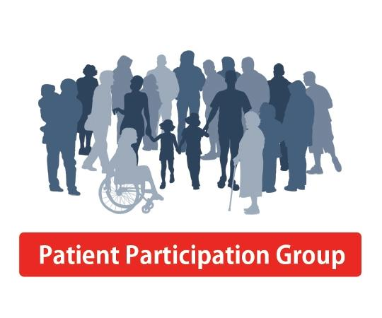
Minutes of the patient of the consultative group meeting
July, 2022
Dr Dutta | Bharti Koteche (Lead) | Punam Tekle (Care co-ordinator)
Juleen Stewart | Asha Pujamula | Nitin Desai
Raj Sood | Juleen Stewart | Agnello Desouza

The above members were invited both face to face / virtually to feedback their opinions regarding the practices performance over the past 12 months.
Firstly, the group thanked the Practice for helping to maintain any effort that has gone into maintain GP healthcare services.
Meeting Commentary
- Friend and Family Tests

The friends and family test results for April, May and June were discussed as well as the annual GP Patient Survey Report
Overwhelmingly the PPG were very satisfied with the majority of the comments being positive especially in terms of the access, responsiveness and continuity of care being provided. It was noted that on the GP Patient Survey Report that our practice scored highest on these aspects. Compared to last years, there was a definite improvement in addition to the amount of time patient felts with the GP.
There were very few negative comments on the Friends & Family Test, which has recently being implemented, Post Pandemic.
Most of it was related to patients feeling, having to wait in the waiting room to see the GP.
The PPG expressed the desire for patients to be seen by the same GP every time .It was explained this will be very difficult to achieve as each GP has different working patters and clinic timings.
It was advised that, since April the practice has started online E-consultation and hopefully this may help alleviate.
Some of the concerns a few patients have regarding waiting times and trying to maintain continuative care.
The PPG were very satisfied with the level of responsiveness of the practice.

- Complaints received

Majority of complaints received over the year were minor issues relating to the reception team .There has been 1 or 2 complaints about disagreements with GP.
Because of the Pandemic, there has been some turnover of the reception team, however with better recruitment this should hopefully improve.
It was also fed back that some patients seemed to be taking their frustration out to the reception team and warning letters have been sent to those patients. Tis does not help with recruitment and retaining of staff.
As a practice we follow the Zero Tolerance policy.
The PPG felt that overall reception staff were excellent and this is reflected in the Friends& Family Test and in the Annual GP Patient Survey where 93% of patients find the receptionist very helpful compared to the national average of 82%.
The overall experience of the GP practice as good as 95% compared to the national average of 72%.

- Online triage system
The PPG were happy with the Accurex System and they were also happy for patients to be referred to the pharmacy for minor ailments. These are new services that has started since April.

- In-house Pharmacist
The practice has recruited an in-house pharmacist to do medication reviews. The PPG was very supportive of this.
The PPG were also supportive for patients to be advised to purchase their on BP machine and O2 SATs monitor as they are fairly inexpensive and can be bought from Amazon.

- Appointments
The PPG were happy with the way the current system is running. Balham mornings are walk in only before 10.30am. Balham evening appointments are triaged/same-day booking.
Some appointments in the evening are being reserved for vulnerable patients /sick children.

- PCN services
The PPG were very satisfied with the increased level of the PCN services (Health & wellbeing Coach, Social Prescriber, Pharmacist , First contact Physio, Paramedic, Psychologist,)hopefully patients will be feeling that they are getting support from local services to help manage their long-term conditions. The PPG were also supportive of the plan to develop to work with other practices in the PCN for patients to have physio reviews on Saturdays and Cervical Smear Tests on Saturdays. With additional diagnostic services with the HCA on Saturday morning and some evening appointments.

Next Meeting will be held in July 2023.

